Exercise 1: Implementing the Singleton Pattern
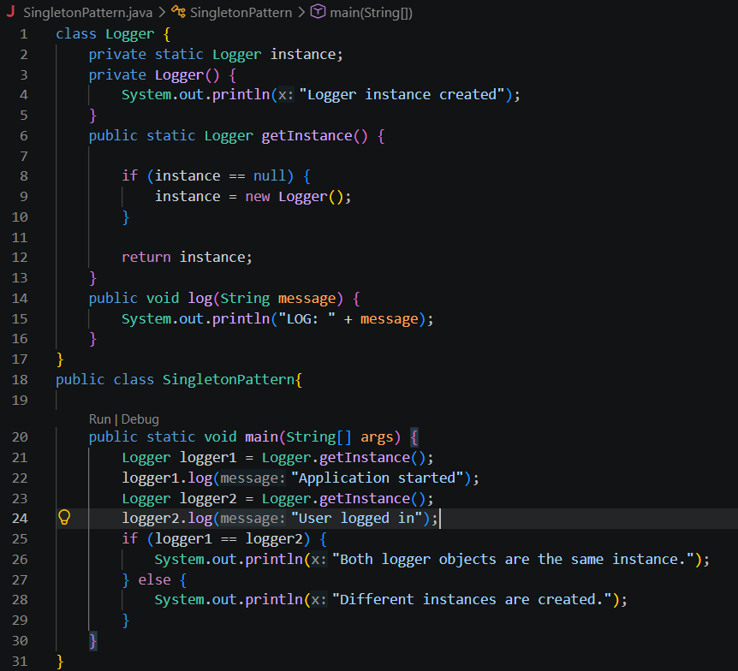
Output:

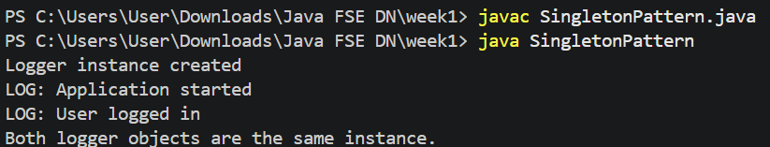

Exercise 2: Implementing the Factory Method Pattern
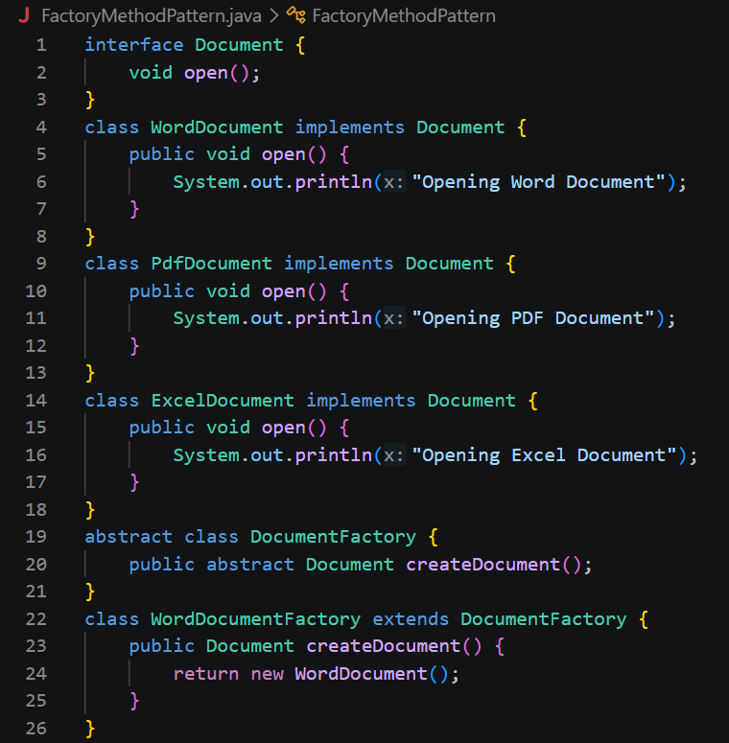
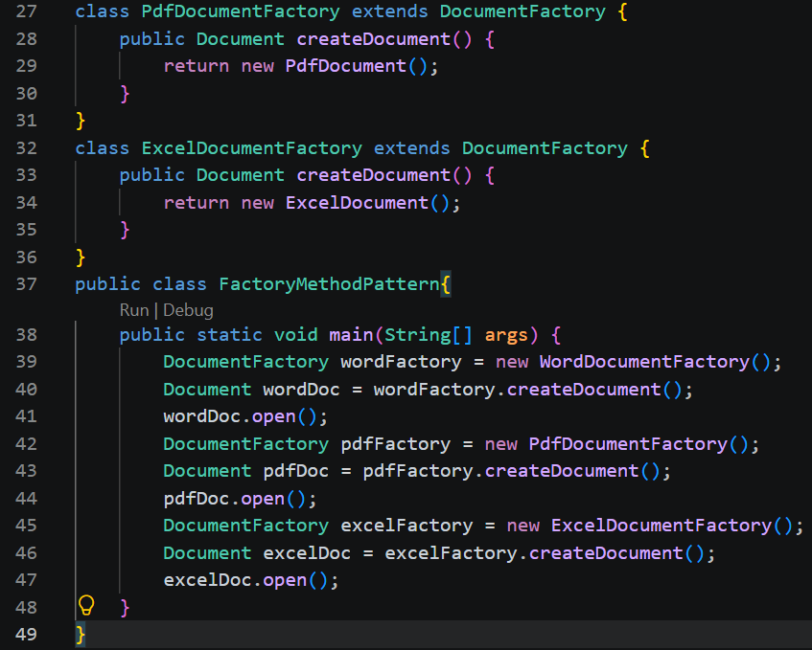

Output:
